Particle model of matter – Cut and paste in
The points of the Particle model of matter
- All matter is made up of very tiny invisible particles.
- Particles have kinetic energy and are always moving
- Spaces exist between particles and the size of the space depends on the state
- As temperature increases, the kinetic energy energy (movement) of particles increases.
- Particles are held to each other by forces of attraction. The strength of these forces (along with the temperature) determine the state of the matter (solid, liquid, gas). Solids have strong forces of attraction so are held tightly together. Gases have very weak forces of attraction so particles move freely.
Particle diagrams - cut and paste (leave a lot of space above and below) and label this model using the words… SOLID, Evaporation, Freezing, GAS, Boiling, condensing, LIQUID, and Melting.
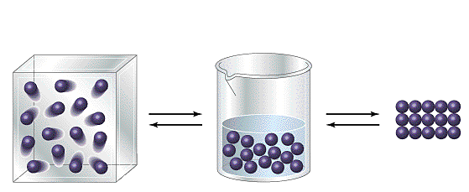
There is one more word, but it is not shown in the diagram – Sublimation. Once your teacher has checked your work ask how the word Sublimation fits in the model.

Cut and paste this table in – EXCEPT for the last column, the explanations in the last column do not match their row. Cut out each rectangle of the last column and glue it into its correct row.
Characteristics of each state of matter |  |  | Explanation using Particle model
GAS | LIQUID | SOLID | Explanation using Particle model
Large distances between particles | Small distances between particles | Particles closely packed together | Point 2 – particles have kinetic energy and are always moving  Point 5 – Solids have strong forces of attraction compared to liquids and gases
Particles move rapidly in all three dimensions | Particles vibrate and translate | Particles vibrate only | Point 5 – In solids the particles are held tightly together so they cannot move and flow. In gases and liquids the particles can move and flow.
Easily compressed | Cannot be significantly compressed | Cannot be compressed | Point 5 – Solid has strong forces of attraction between the particles, gases have weak forces of attraction
Takes up all volume of the container  Takes the shape of the container | Settles to the bottom of the container and takes the shape of the container at this point | Has its own shape shape regardless of container | Point 3 – In solids and liquids there is very little space between the particles.
Flows | Flows | Does not flow | Point 5 – In solids the particles are held tightly together so the shape doesn’t change. In gases particles can move freely so the volume and shape can change easily

